

SIMATS ENGINEERING
Saveetha Institute of Medical and Technical Sciences Chennai- 602105
Student Name: USHA NANDHINI.P Reg. No : 192511263
Course Code: CSA 1221 Slot: B
Course Name: COMPUTER ARCHITECTURE
Course Faculty: Dr. K. VIJAYA BHASKAR

Project Title: INSTRUCTION SET ARCHITECTURE SIMULATOR
Module Photographs: (3 photographs –Module Photo, Individual student contribution module work in the project and presentation image)
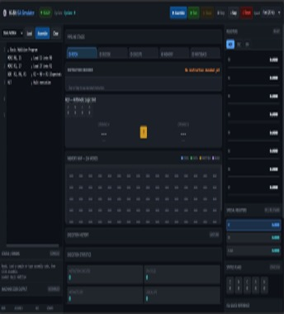
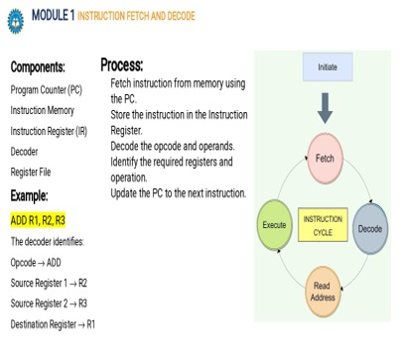
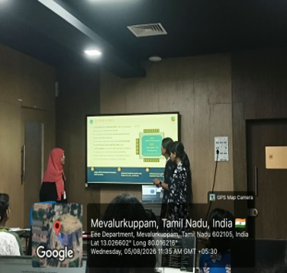
Project Description: (here you write what you did in this project (contribution) including Model Description
The Instruction Set Architecture (ISA) Simulator is a software-based project developed to provide a practical understanding of how a processor interprets and executes machine-level instructions. The simulator creates a virtual CPU environment containing essential components such as registers, memory, Arithmetic Logic Unit (ALU), Program Counter (PC), Instruction Register (IR), and status flags. It allows users to write or load simple assembly instructions such as LOAD, STORE, MOV, ADD, SUB, AND, OR, JMP, and HALT, and observe their execution within the simulated processor. The system follows the basic fetch, decode, execute, and store instruction cycle, where each instruction is fetched from memory, decoded to identify its operation and operands, executed by the appropriate processor unit, and the result is stored in a register or memory location. The simulator also displays changes in register values, memory contents, flags, and the Program Counter, helping users trace program execution step by step. The main purpose of this project is to simplify the study of computer architecture and instruction-level processing by providing an interactive environment without requiring physical processor hardware. Overall, the ISA Simulator serves as an educational tool that connects assembly language concepts with the internal operations of a CPU and can be further enhanced with features such as pipelining, cache memory, interrupts, multiple addressing modes, and processor performance analysis.

Student Signature Guide Signature

